Automated HeLa Cell and Nucleus Segmentation using Image Processing and Deep Learning

|  |  |  |
| --- | --- | --- |
| Mukunda Hosangadi  *School of Computer Science*  *Engineering*  *VIT University*  Chennai, India mukunda1808@gmail.com | Sumedh Kudale  *School of Computer Science*  *Engineering*  *VIT University*  Chennai, India sumedhkudale2@gmail.com | Ganesh Reddy G  *School of Computer Science*  *Engineering*  *VIT University*  Chennai, India ganesh.buddu@gmail.com |

*Abstract*—Accurate segmentation of cells and their internal components such as the nucleus serves as the foundation for a wide variety of biological research and diagnostics, it becomes even more critical for this task when evaluating cancer models such as cell lines such as HeLa. Manual segmentation is timeconsuming and user-dependent. In this paper we propose an automated solution for HeLa cell and nuclei segmentation, based on both traditional image processing techniques and deep learning, on a difficult image dataset. The initial preprocessing of background normalization and cell region enhancement is performed on images at their original resolution using MATLAB, and then cell body segmentation is performed on the preprocessed images downsampled to 256x256 as an input to the U-Net deep learning model (implemented in Python). Then, an image processing pipeline designed in MATLAB makes use of the intensity information of the raw image together with predicted cell mask information to help segment the nuclei, including edge detection, morphological operations and rule-based verification steps. The dataset is a 300-image stack sampled from Serial Block-Face Scanning Electron Microscopy (SBF-SEM). Typical metrics such as Jaccard Index (IoU), Dice Coefficient, F1-Score and Pixel Accuracy are used to evaluate the performance of cell and nucleus segmentation. The U-Net model achieved high accuracy for cell segmentation (Mean IoU: 0.9582, Mean Dice: 0.9781), and the subsequent nucleus segmentation pipeline also demonstrated great performance (Mean Jaccard: 0.8951, Mean Dice: 0.9215). This combined approach provides an effective and automated solution for HeLa cell and nucleus segmentation, facilitating further analysis.

*Keywords*—HeLa Cells, Cell Segmentation, Nucleus Segmentation, Deep Learning, U-Net, Image Processing, SBF-SEM, Automated Segmentation.

# I. INTRODUCTION

S

EGMENTATION of cell structures under microscopy images is one of the most complicated works in biological image analysis. It permits close examination of features such as cell morphology, behavior, and interactions. This is quite crucial to disease and biological process comprehension. One of the most widely utilized human cell cultures, HeLa cells, is thoroughly studied, particularly in the field of cancer studies [2]. Correct segmentation of the HeLa cell body and nucleus is of extreme importance in studying cellular morphology, responses changes, and nuclear properties under varying experital conditions.

Though widely used today with manual segmentation, it is extremely time-consuming, and is susceptible to interobserver variability, and therefore highly impracticable for large datasets. Segmentation by machine is a likely choice. It offers objectivity, reproducibility, and high throughput. These cover a broad range of techniques, ranging from the classical image processing methods based on thresholding, edge detection, and morphological processing [1] to higher-level machine learning and deep learning methods [3], [4].

Deep learning, i.e., Convolutional Neural Networks (CNNs) like the U-Net architecture [5], has shown remarkable excellence in biomedical image segmentation tasks owing to its capacity to directly conclude sophisticated hierarchical features from data. However, deep learning models are generally amounts of annotated training material [6] and considerable computational resources. In addition, splitting some subcellular organization like the nucleus of a previously seg-mediated cell remains largely problematic, especially in collaborating with varying intensity, texture, and overlapping structures [7]. Techniques have also been developed to track cells over time, including motion detection and matching approaches [8], [9].

The article presents a combination approach that employs advantages of classical image processing and deep learning for robust HeLa cell and nucleus segmentation. We employed a unique data set of serial block-face scanning electron microscopy (SBF-SEM) [11], which offers a high resolution 3D context but is challenging due to noise and complex cellular environments. Our pipeline first preprocessed the images using MATLAB to enhance cell regions. Then, a U-Net model, being in Python, was trained on these pre-processed images performs the first cell body segmentation. Finally, a particular MATLAB-based image processing algorithm enhances nucleus segmentation through intensity analyzing profiles, edges, and spatial relationships in the predicted cell mask. The performance is objectively assessed with standardized tests [12].

The central arguments of this work are:

* A specially configured preprocessing pipeline for cell structure features in SBF-SEM images for further segmentation.
* Deployment and testing of a U-Net model for HeLa cell body segmentation of the preprocessed data.
* Designing an image processing pipeline for precise nucleus segmentation, depending on the cell output segmentation model.
* Quantitative comparison of cell and nucleus segments performance against several standard measures.

# II. LITERATURE REVIEW

Cell segmentation is at the forefront of biomedical research, particularly for cancer research with widely used cell lines like HeLa. The division of cellular structures from microscopy images enables analysis of morphological characteristics, which is a prerequisite to understanding biological and disease processes [10]. The discipline has, throughout the years, developed from hand segmentation—which is laborintensive and subjective—to computer techniques using both traditional image processing techniques and recent deep teaching methods.

Traditional image processing techniques have proved effectiveness in HeLa cells segmentation. Duque-Vazquez et al. [1] illustrated a digital image processing-algorithm for detection of shape and nucleus of HeLa cells, highlighting the possibility of non-deep learning approaches. Likewise, Karabag et al. [3]˘ conducted a detailed comparison between a traditional image processing algorithm and four deep learning architectures, discovering that the conventional approach would sometimes exceed deep learning methods for specific tasks such as nuclear envelope segmentation in terms of certain metrics.

The recent inception of ’deep learning’ has greatly improved the cell segmentation field. U-Net, which was proposed by Ronneberger et al. [5], as an architecture foundation for biomedical image segmentation due to its efficient encoderdecoder network with skip connections, with proficiency in handling restricted data conditions typical of medical imaging. Building on that basis, scholars have come up with hybrid methods that use pre-trained networks (usually trained on large datasets such as ImageNet [13]) with U-Net architectures. Nath et al. [4] contrasted some hybrid CNN models (VGG19-UNet, Inception-U-Net, and ResNet34-U-Net) for multi-class segmentation of HeLa cells, which shows the possible advantages of transfer learning.

For volumetric data, techniques like the one described by Reyes-Aldasoro et al. [7] utilize segmentation methods through stacks of 3D images, occasionally with high precision through standard image processing methods used slice-by-slice or volumetrically. The worth of good quality ground truth data used to train deep models has been addressed by initiatives like the ”Etch a Cell” citizen science project by Spiers et al. [6] which utilizes crowd-sourced manual segmentation to produce stable training data such as nuclear envelope segmentation in electron microscopy.

Newer methods have been focused on object instance segmentation and tracking. Scherr et al. [9] proposed a combination of CNN-based distance predictions with graph-based cell tracking and segmentation matching, solving the cell movement and division issues. For whole-cell organelle segmentation, Heinrich et al. [10] showed comprehensive volume electron microscopy techniques combined with deep learning for in-depth cellular structure analysis.

The hybrid approach proposed in this paper effectively integrating conventional and deep learning methodologies, using a U-Net model for early cell body segmentation followed by a rule-based image processing pipeline for nucleus identification. It is a practical direction towards utilizing the strengths of each paradigm—the very powerful feature learning capacities of neural networks and the interpretability and efficacy of classical methods for well-defined, specific sub-tasks.

# III. DATASET

The information utilized in this study is a stack of 300 grayscale images obtained by Serial Block-Face Scanning Electron Microscopy (SBF-SEM) of HeLa cells [3]. This imaging modality provides high-resolution volumetric information by repeatedly imaging the block face of a sample after removing a thin section [11]. The result is a set of ordered 2D images representing successive sections through the specimen. Raw data was delivered as a TIFF image stack, where the 300 individual images are successive slices throughout the cellular volume. Each original image has dimensions 2000x2000 pixels. For preprocessing, these original resolution images were used. The sequential nature of the stack records the changing morphology of cells and nuclei as the slicing progresses through the volume. This dataset presents usual problems associated with electron microscopy, including variations in staining, noise, and the presence of intricate intracellular and extracellular structures. A ground truth segmentation mask corresponding to every image slice was also available for training and testing purposes [3].

# IV. METHODOLOGY

Our proposed research process has three main phases: image pre-processing (on MATLAB), segmentation of cell body with a U-Net model (Python/TensorFlow), and nucleus segmentation from a user-specified image processing pipeline (MATLAB).

## A. Image Preprocessing

The original native SBF-SEM images (2000x2000 pixels of the dataset were initially pre-processed with DIP in MATLAB to separate the foreground cells from the background. The output was used as the inputs to the U-Net model. This process involves the following steps:

1. Read Image: All images of the 300-slice stack was read in sequence. Let the original image be *Iorig*. (Fig. 1a shows an example original image).
2. Gaussian Filtering: A Gaussian blur filter with (sigma=2) was used in the image *Iorig* to smooth noise

(*Igauss*).

1. Otsu Thresholding: Otsu’s gray thresholding method was applied to *Igauss* to determine a suitable threshold value, threshold the image with it and get as output a binary image that separates foreground (cells, structures) from background (*BWotsu*). (Fig. 1b shows the example of a thresholded image).
2. Inversion: The *BWotsu* binary image was inverted so the potential cell areas became white (value 1 or 255) and the background went black (value 0). This enables

Preprocessing steps applied to original 2000x2000 images (shown resized for visualization). (a) Original grayscale image section. (b) Image after Gaussian filtering and Otsu thresholding. (c) Inverted binary image. (d) Final preprocessed binary image after area opening, used as input for U-Net training (after resizing).

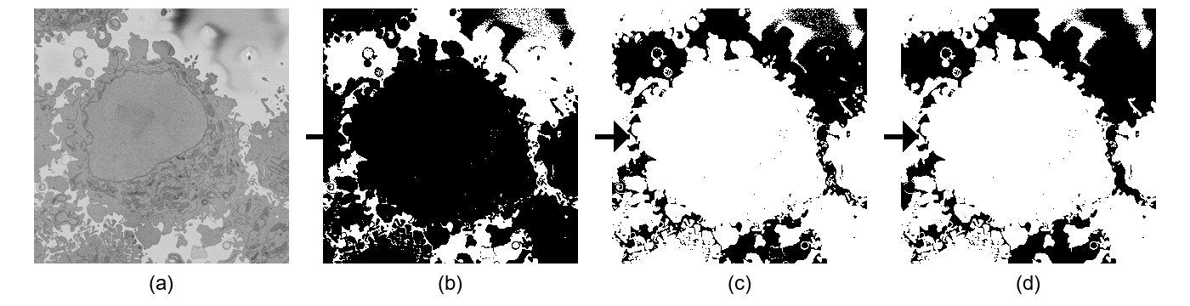

Fig. 1.

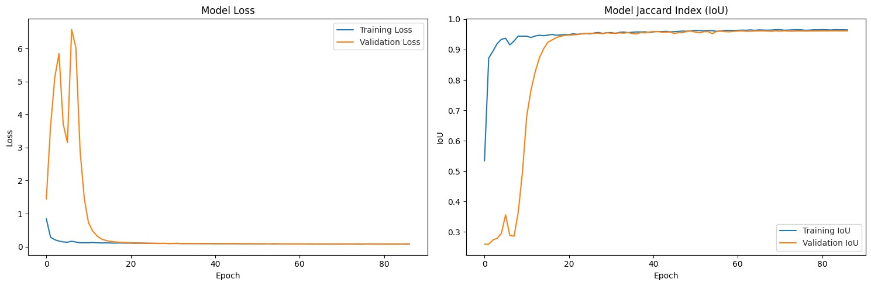

us to visualize the cell structures as objects in the image. (*BWinv*). (Fig. 1c is a sample of the inverted image).

1. Area Opening: Small white areas (noise or small debris) were removed by a morphological process named area opening, retaining only the connected components larger than 3000 pixels (*BWfinal*). (Fig. 1d shows the final preprocessed image for this example picture).

The binary images that resulted (*BWfinal*), remaining at the original 2000x2000 resolution, feed input to the later used UNet model. This preprocessing step effectively yields noisy binary masks with possible cellular areas as separated to the foreground.

## B. Cell Segmentation using U-Net

A U-Net model, expressed in Python via TensorFlow and Keras, were used for the core task of segmenting the HeLa cell in focus from the preprocessed images (*BWfinal*).

1. *Model Architecture:* The conventional U-Net architecture [5] was utilized, as earlier mentioned (encoder-decoder architecture with skip connections). Preprocessed binary images (*BWfinal* at 2000x2000 resolution) were reduced to 256x256 pixels before passing them on to the neural network. The last layer used a 1x1 convolution and a sigmoid activation function to generate pixel-wise probabilities for the cell class.
2. *Training Details:* The data (300 preprocessed images and ground truth masks) was split into training, validation, and test sets. Data augmentation techniques (flips, rotation, elastic transformation, brightness/contrast adjustments through Albumentations) were used during training. The model utilized the Adam optimizer, binary cross-entropy loss, and accuracy monitored, IoU, and Dice Coefficient. Callbacks to save the best model (on validation IoU), rate drop at plateau, and early stopping (patience=15) were employed. Training was conducted for up to 100 epochs (batch size 8), early stopping and best weights restoring from epoch 72 (validation IoU 0.96193).
3. *Prediction:* The trained U-Net model generated probability maps of the test images, thresholded at 0.5 to produce binary cell segmentation masks.

## C. Nucleus Segmentation

After cell body segmentation, DIP was used again implemented in MATLAB to isolate the nucleus. This process accepts the original grayscale image (resized to 500x500 for

Fig. 2. Training history of the U-Net model for cell segmentation. Left:

Training and Validation Loss per epoch. Right: Training and Validation Jaccard Index (IoU) per epoch. Early stopping occurred at epoch 87, restoring weights from epoch 72.

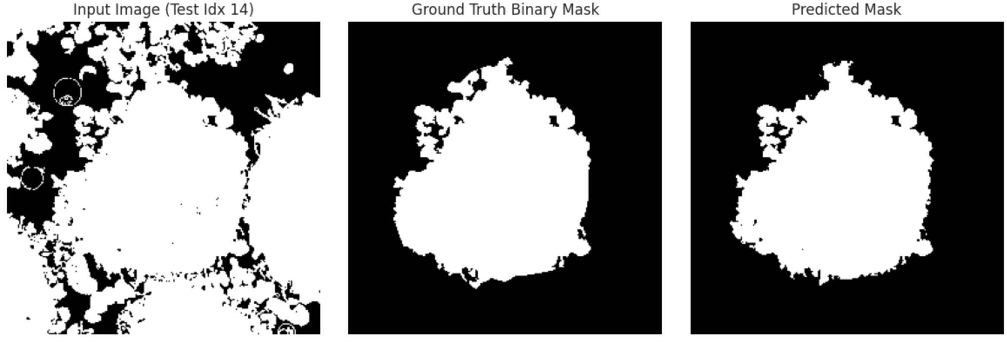

Fig. 3. Sample U-Net segmentation result on a test image (Test Idx 14). Left: Input image (preprocessed binary image fed to U-Net). Middle: Ground Truth binary mask for the cell. Right: Predicted binary mask from the U-Net model.

this step) and the predicted cell mask (also resized to 500x500) as inputs. The most important steps are shown in Fig. 4.

1. Edge Enhancement: Input grayscale image *I* (resized to 500x500, Fig. 4a) is smoothed (Gaussian *σ* = 0*.*2) to filter out noise. It was then passed through a standard deviation filter to highlight local variations of intensity. Canny edge detection detects potential nuclear borders (Fig. 4b).
2. Edge Dilation and Inversion: Edges are dilated (diamond SE, size 2) (Fig. 4c) and inverted to form white candidate objects (Fig. 4d).
3. Object Filtering: Candidates are cleaned using area opening (*>*300 pixel objects are retained) and hole filling (Fig. 4e). Size filtering (400-40000 pixels) is done.
4. Verification Steps: Verification Steps are utilized to affirm if the prospective nucleus candidates pass through the metrics to find appropriate candidates. (Fig. 4f):
   * *Distance Check:* Candidates distant (*>*110 pixels) from the cell centroid are removed.
   * *Containment Check:* Candidates mostly outside the cell mask (*<*150 pixels allowed outside) are removed.
   * *Roundness Check:* Circularity is calculated (4*π* × Area*/*Perimeter2). Non-round objects (metric *<* 0.1) are removed after area opening (*>*500 pixels objects are retained).
   * *Size Selection:* The biggest remaining candidate is selected.
5. Refining/Closing: The selected candidate’s boundary is refined using an intensity-based mask (threshold 94130 on original image), comparing size and proximity. The matched object from the intensity mask is selected, dilated (sphere SE, size 3 or 4 depending on candidate

|  |
| --- |
| Fig. 4. Nucleus segmentation steps using image processing (MATLAB). (a) Original grayscale input image (resized to 500x500). (b) Edges detected using Standard Deviation filter and Canny edge detector. (c) Dilated edges. (d) Inverted image creating potential nucleus shapes. (e) Filled holes after area opening.  (f) Result after verification steps (distance, containment, roundness, size selection). (g) Final detected nucleus after refinement/closing step. |

size), and filled to form the final nucleus mask (Fig. 4g).

The outcome is the final binary nucleus mask.

# V. RESULTS AND DISCUSSION

The performance of both cell segmentation and nucleus segmentation were validated by comparing the predicted masks with the ground truth masks using 4 metrics.

## A. Evaluation Metrics

The following metrics were utilized to measure segmentation accuracy:

* Jaccard Index (Intersection over Union - IoU): Measures the overlap between the predicted segmentation (*A*) and the ground truth (*B*).

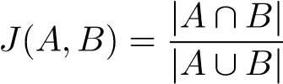 (1)

* Dice Coefficient (F1-Score): Like IoU, it measures overlap, computed as twice the intersection divided by the sum of the areas. In binary segmentation, Dice is equal to the F1-Score.

Dice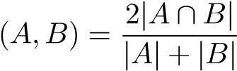 (2)

* Pixel Accuracy: The ratio of pixels correctly classified.

Accuracy 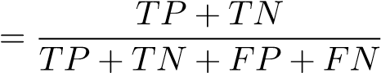 (3)

where TP, TN, FP, FN are True Positives, True Negatives, False Positives, and False Negatives, respectively.

* Normalized Probabilistic Rand Index (NPR): (Used for nucleus evaluation) Quantifies the similarity between two clusterings (segmentations), normalized to compensate for chance agreement [12]. It varies from -1 to 1, where 1 signifies perfect agreement. The equation includes the actual Rand Index (I), its expected value (*IE*), and its maximum possible value (*IM*):

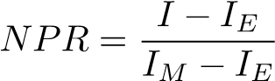 (4)

Values for IoU, Dice, F1, and Accuracy vary from 0 to 1, with 1 reflecting ideal segmentation.

## B. Cell Segmentation Evaluation

The U-Net model was tested on the assigned test set (45 images). The overall performance measures are reported in Table I. The model showed excellent accuracy with a mean IoU of 0.9582 and a mean Dice coefficient (F1-Score) of 0.9781. This represents an extremely good overlap between the estimated cell masks and the ground truth annotations.

Fig. 5 shows the performance trend over all 300 images in the data set (tested after training). The plots indicate high performance across most of the image stack consistently. Significant dips in performance happen largely at the very first and last slices of the stack, where the cell is entering or leaving the field of view and hence only partially captured or poorly delineated. The Jaccard, Dice, and F1 scores show strongly correlated trends.

|  |
| --- |
| Fig. 5. Cell segmentation performance metrics per image across the entire 300-image dataset. Top-Left: Jaccard Index (IoU). Top-Right: Dice Coefficient. |

Bottom-Left: F1-Score. Bottom-Right: Pixel Accuracy.

TABLE I

SUMMARY PERFORMANCE METRICS FOR U-NET CELL SEGMENTATION

# (N=45 TEST IMAGES)

|  |  |  |  |
| --- | --- | --- | --- |
| Metric | Mean | Median | Std Dev |
| IoU (Jaccard) | 0.9582 | 0.9709 | 0.0425 |
| Dice Coefficient | 0.9781 | 0.9852 | 0.0244 |
| F1-Score | 0.9781 | 0.9852 | 0.0244 |
| Pixel Accuracy | 0.9919 | 0.9922 | 0.0033 |

# TABLE II

SUMMARY PERFORMANCE METRICS FOR NUCLEUS SEGMENTATION PIPELINE (N=300 IMAGES)

|  |  |  |  |
| --- | --- | --- | --- |
| Metric | Mean | Median | Std Dev |
| IoU (Jaccard) | 0.8951 | 0.9683 | 0.2177 |
| Dice Coefficient | 0.9215 | 0.9839 | 0.2050 |
| F1-Score | 0.9215 | 0.9839 | 0.2050 |
| NPR | 0.9603 | 0.9908 | 0.1019 |

## C. Nucleus Segmentation Evaluation

The performance of the MATLAB-based image processing pipeline for nucleus segmentation was evaluated over the entire 300-image dataset by comparing its output to the ground truth nucleus masks. The performance metrics used were Jaccard Index, Dice Coefficient, F1-Score, and Normalized Probabilistic Rand Index (NPR).

Summary statistics for nucleus segmentation performance are given in Table II. The pipeline produced a mean Jaccard index of 0.8951 and a mean Dice/F1 value of 0.9215. The mean NPR was 0.9603. These values indicate a good level of accuracy for segmentation of the nucleus, though lower than for cell body segmentation, reflecting the more difficult task of segmenting the smaller, at times less pronounced, nuclear structure. The standard deviations are fairly high, indicating greater variation in performance across the image stack than with cell segmentation.

Fig. 6 illustrates the per-image performance for the nucleus segmentation task. It is consistent with the cell segmentation results, performance is fairly consistent and high in the middle part of the image stack where the nucleus is easily seen and well-defined. Performance drops drastically at the start and end of the stack, where the nucleus can be absent, only partially sectioned, or hard to define from the surrounding cytoplasm.

## D. Discussion

The hybrid strategy introduced deep learning for coarse cell body localization and conventional image processing for finegrained nucleus segmentation. The MATLAB pre-processing in the beginning was found to be effective in producing appropriate inputs for the Python-based U-Net, allowing it to perform high-fidelity cell segmentation. The following MATLAB nucleus segmentation pipeline showed that it could utilize intensity, edge, and shape information from the original image, under the guidance of the cell mask, to accurately identify and delineate the nucleus. The multi-stage verification process was key to handling ambiguities and reducing false positives. The quantitative results, corroborated by visual examples (Fig. 3 and Fig. 4), validate the effectiveness of this combined strategy for the specific challenges posed by the SBF-SEM dataset. The observed performance drop at the stack boundaries is inherent to analyzing partial structures in 2D slices from a 3D volume.

|  |
| --- |
| Fig. 6. Nucleus segmentation performance metrics per image across the entire 300-image dataset. Top-Left: Jaccard Index. Top-Right: Dice Coefficient. Bottom-Left: F1-Score. Bottom-Right: Normalized Probabilistic Rand Index (NPR). |

# VI. CONCLUSION

This work introduced an automated pipeline merging deep learning and conventional image processing for cell and nuclei segmentation from a 300-image SBF-SEM dataset. A U-Net model, implemented with Python and trained on MATLABpreprocessed images, had high accuracy in segmenting the cell bodies, with a mean Dice score of 0.9781. A rule-based image processing algorithm used after that, coded in MATLAB, utilizing edge detection, morphological operations, and checks based on distance, containment, and shape, precisely segmented the nuclei with a mean Dice score of 0.9215.

The outcomes show that the hybrid process can successfully automate the segmentation process, generating accurate masks for the cell and the nucleus, which can facilitate further quantitative biological study. The approach was found to be robust for most of the image stack where cellular structures were clearly defined.

Extensions could include taking the pipeline further to segment other organelles within the cell [10]. Furthermore, investigating 3D segmentation strategies that take advantage of the volumetric nature of the SBF-SEM data may also enhance consistency and accuracy, particularly for structures only partially visible within single slices. Making the approach more flexible to accommodate different cell types or imaging modalities would also be a useful addition.

# REFERENCES

1. E. F. Duque-Vazquez, R. E. Sanchez-Yanez, N. Saldana-Robles, M. F.˜ Leon-Galv´ an, and J. Cepeda-Negrete, “HeLa cell segmentation using´ digital image processing,” *Heliyon*, vol. 10, no. 5, p. e26520, Feb. 2024.
2. E. F. Duque-Vazquez *et al.*, “Hela Cell Segmentation Using Digital Image Processing,” *SSRN Electronic Journal*, Jul. 2023. [Online]. Available: https://dx.doi.org/10.2139/ssrn.4498555
3. C. Karabag, M. L. Jones, C. J. Peddie, A. E. Weston, L. M. Collinson,˘ and C. C. Reyes-Aldasoro, “Semantic segmentation of HeLa cells: An objective comparison between one traditional algorithm and four deeplearning architectures,” *PLoS ONE*, vol. 15, no. 10, p. e0230605, Oct. 2020.
4. S. K. Nath *et al.*, “Hybrid Deep-Learning Multi-Class Segmentation of Hela Cells in Reflected Light Microscopy Images,” *SSRN Electronic Journal*, Aug. 2023. [Online]. Available: https://dx.doi.org/10.2139/ssrn. 4543079
5. O. Ronneberger, P. Fischer, and T. Brox, “U-Net: Convolutional Networks for Biomedical Image Segmentation,” in *Medical Image Computing and Computer-Assisted Intervention – MICCAI 2015*, ser. LNCS, vol. 9351. Cham: Springer, 2015, pp. 234–241.
6. H. Spiers *et al.*, “Deep learning for automatic segmentation of the nuclear envelope in electron microscopy data, trained with volunteer segmentations,” *Traffic*, vol. 22, no. 7, pp. 240–253, Jul. 2021.
7. C. C. Reyes-Aldasoro *et al.*, “Volumetric Semantic Instance Segmentation of the Plasma Membrane of HeLa Cells,” *bioRxiv*, Apr. 2021.

[Online]. Available: https://doi.org/10.1101/2021.04.30.442156

1. F. Boukari and S. Makrogiannis, “Joint level-set and spatio-temporal motion detection for cell segmentation,” *BMC Med. Genomics*, vol. 9, no. 2, p. 31, 2016.
2. T. Scherr, K. Loffler, M. B¨ ohland, and R. Mikut, “Cell segmentation¨ and tracking using CNN-based distance predictions and a graph-based matching strategy,” *PLoS ONE*, vol. 15, no. 12, p. e0243219, Dec. 2020.
3. L. Heinrich *et al.*, “Whole-cell organelle segmentation in volume electron microscopy,” *Nature*, vol. 599, no. 7883, pp. 141–146, Nov. 2021.
4. T. J. Deerinck, E. Bushong, A. Thor, and M. H. Ellisman, “NCMIR Methods for 3D EM: A New Protocol for Preparation of Biological Specimens for Serial Block-Face SEM Microscopy,” National Center for Microscopy and Imaging Research (NCMIR), Univ. California, San Diego, La Jolla, CA, USA, Tech. Rep., 2010. [Online]. Available: https: //ncmir.ucsd.edu/sbem-protocol
5. R. Unnikrishnan, C. Pantofaru, and M. Hebert, “Toward objective evaluation of image segmentation algorithms,” *IEEE Trans. Pattern Anal. Mach. Intell.*, vol. 29, no. 6, pp. 929–944, Jun. 2007.
6. J. Deng, W. Dong, R. Socher, L.-J. Li, K. Li, and L. Fei-Fei, “ImageNet: A large-scale hierarchical image database,” in *Proc. IEEE Conf. Comput. Vis. Pattern Recognit. (CVPR)*, Miami, FL, USA, Jun. 2009, pp. 248– 255.